

Table Of Contents (Sections, not pages)

1. Description
2. Nav Bar
3. Colours Section
4. Typography
5. Description

A Very brief description of my site would be “A site that is still W-I-P”. If I was truly making a portfolio site, this would not be the final product. This is a brief mock-up of what I want, basically. This site serves to show prospective employees my work.

1. Nav Bar



The way this nav bar works is like so: Each tab brings up a separate portion of text. Each tab has it’s own hover, clicked, and active states thanks to Jquery UI/Mobile. As such, this does not need to be handled by me.

As this is JavaScript/Jquery, the user will not be able to use these if JavaScript is disabled.

1. Color Swatch

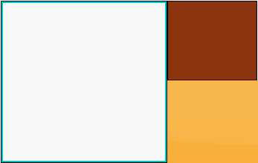

The background is a solid grey (#F8F8F8)

The Logo goes from a Brown, to Dark Brown, straight to a light brown. (#f0b7a1 to #8c3310 to #752201 to #bf6e4e)

The nav bar is an orange color (#F8B64A)

1. Typography

The Font of the entire site(Excluding the Logo) is the default font used by Jquery. The size is the default sizes for headers and body elements

The font of the Logo is from Google Fonts. It is called “Prosto One”. The size of the main name is 2em, while the tagline is at 0.5em